What will we be learning?  Unit RO45 – Sports Nutrition | Why this? Why now?  This unit is a compulsory coursework unit for the Sport Science course. This is the final unit taught in Year 11 as students can draw on content learned from previous units taught in the course. | Key Words:  Balanced diet  Calories  Energy balance  Macronutrients  Micronutrients  Hydration  Carbo loading  Dietary supplements  Overeating  Undereating  Dehydration  Malnutrition  Diet plan
What will we learn?
LO1 - Know the nutrients needed for a healthy, balanced diet
LO2 – Understand the importance of nutrition in sport
LO3 – Know about the effects of a poor diet on sports performance and participation.
LO4 - Be able to develop diet plans for performers
What opportunities are there for wider study?
Sixth form studies
- Cam Tech Sport
- A level PE
Careers/degree courses
- Sports science
- Physiotherapy
- PE teacher
How will I be assessed?
- Set OCR assignments under teacher supervision
CAM NAT – SPORT SCIENCE
UNIT RO45

LO1 - KNOW THE NUTRIENTS NEEDED FOR A HEALTHY, BALANCED DIET  - Characteristics of a balanced diet  - Nutrients (macronutrients and micronutrients) | 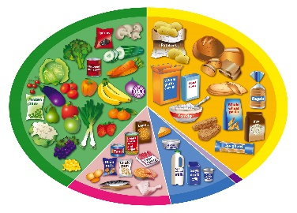
LO2 – UNDERSTAND THE IMPORTANCE OF NUTRITION IN SPORT
- The importance of nutrition before, during and after exercise
- Reasons for the varying dietary requirements of different activity types
- Dietary supplements and issues associated with their use.

LO3 – KNOW ABOUT THE EFFECTS OF A POOR DIET ON SPORTS PERFORMANCE AND PARTICIPATION.

- Malnutrition
- Effects of overeating on sports performance and participation
- Effects of undereating on sports performance and participation
- Effects of dehydration on sports performance and participation

LO4 - BE ABLE TO DEVELOP DIET PLANS FOR PERFORMERS  - Design a diet plan for a selected sports performer  - Evaluate effectiveness of the diet plan | 